Turning Stem Cells into Insulin-Producing Cells
Stem cells hold tremendous potential as a source of insulin-producing cells that could be placed in a BioHub. That’s because stem cells have the potential to become virtually any kind of cell.
Our challenge is to “push” stem cells down the path we want them to go – to emerge as cells that sense glucose and secrete insulin. To accomplish that, DRI scientists are working with a variety of adult stem cells.
A novel source of insulin-producing cells
An area that has sparked great interest is the discovery of stem cells in the "biliary (BILL-ee-air-ee) tree" – a network of drainage ducts that connect the liver and pancreas to the intestine.
DRI researchers are collaborating with Dr. Lola Reid from the University of North Carolina, a recognized expert in liver development who discovered this line of stem cells.
A key benefit is that these are pancreatic "precursor" cells - that is, cells that already have started down the path to become pancreatic cells. This could make it easier for scientists to produce a higher, more efficient yield of beta cells.
In the lab, scientists have instructed the biliary cells to mature into islets. These islet structures produced insulin and c-peptide (a component of natural insulin production) in response to glucose. Transplanting these structures into diabetic mice dramatically improved blood sugar control.
Ongoing studies are aimed at establishing that these cellls can be used to reverse diabetes in pre-clinical models.
Read more about this research in the prestigious journal Stem Cells.
Have questions about stem cells? Learn more from our Stem Cell FAQ.
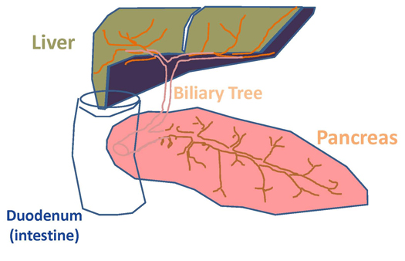

Transforming Other Cell Types into Insulin‐Producing Cells
When working with stem cells, scientists take a cell at its earliest stages of development – and push it down a long path, to become an islet‐type cell.Reprogramming cells could offer a short cut. With this approach, scientists take a more mature cell type and “reprogram” it, transforming it directly into an insulin‐producing cell.
Using "the rest" of the pancreas
To accomplish this, the DRI has been focusing on the “acinar” (or exocrine) tissue of the pancreas. Acinar cells make up almost 98 percent of the organ. They do not produce insulin; rather, they help process food by producing digestive enzymes. One of the interesting features of this tissue is its ability to be transformed into insulin-producing cells.
Typically, scientists have discarded acinar tissue after they have isolated and removed islets cells from a pancreas. Now, DRI researchers are successfully reprogramming acinar tissue into insulin-secreting cells.
The DRI's novel strategies have produced cells that secrete insulin in response to glucose with total insulin levels comparable to those of native islets. Preliminary experiments showed that it's also possible to reprogram previously frozen acinar tissue. This could be important for clinical islet transplantation because it might afford a second infusion of insulin-producing cells from the same donor down the line.
Converting skin cells
DRI Federation collaborators at the University of Milan, Italy, have developed a method to convert human skin cells into insulin-secreting cells. The process involves "fibroblasts" - a type of cell found throughout the human body. In this approach, the focus is on skin fibroblasts.
Basically, researchers briefly expose the cells to an agent that "relaxes" or "loosens" their DNA. Once relaxed, the cell can be pushed into another developmental direction - in this case, to become insulin-producing beta cells.
These cells, named pancreatic epigenetic converted cells (epiCC), show all the characteristics of mature beta cells. In experiments published in Proceedings of the National Academy of Sciences (PNAS), the Italian team demonstrated that epiCC injected into diabetic mice quickly restored normal blood glucose levels.
These cells can be derived from a patient's own skin cells. This would eliminate the threat of foreign tissue rejection and therefore the need for immunosuppressants. They also would provide a potentially limitless supply of insulin-producing cells.
The next steps are to use human skin cells with the goal of testing these cells in clinical trials.

